- Instrumental variable pitch
  - Substantive question: What is the impact that the increased financial security that receiving public benefits grants to recipients upon political attitudes and integration outcomes?
    - Do those who receive public benefits, and thus feel more financially secure, attribute their increased security to the government responsible for dispersing said benefits?
      - This speaks to multiple different literatures. The ones that I am personally most interested in are the inequality and welfare literatures: do benefit recipients “reward” the government with warmer attitudes towards the state when the salience of welfare programs is higher to them because they’ve recently been or will soon be a beneficiary of a program? But the fact that our sample contains immigrants also allows us to make a really interesting contribution to that literature: can the government “buy loyalty” from recent immigrants through benefit programs?
  - Problem: both financial satisfaction and benefit recipient status are obviously highly endogenous, contingent upon both observed characteristics such as income, expenses, etc. and unobserved ones such as underlying personality characteristics.
  - Possible instrumental solution: the proximity to the likely next benefit dispersal period (start or end of the month) represents exogenous variation in how financially satisfied respondents are. This impacts, but is not impacted by, the self reported life financial satisfaction of respondents who receive public benefits, making it good for instrumental variable purposes.
    - Important caveat: I would definitely need to actually go and establish some kind of verification that these programs were actually likely to be dispersed on the start or end of the month. I would likely need assistance with this on some of the QC govt websites (Possibly Thomas if he’s interested in coming on with this project?)
  - Below is what makes me think this might be a viable instrument: we clearly see that benefit recipients have higher predicated values of reported higher/lower financial satisfaction towards the end or start/middle of the month, which is what we would expect to see if this was the case, as well as the fact that this is flat with non-recipients.
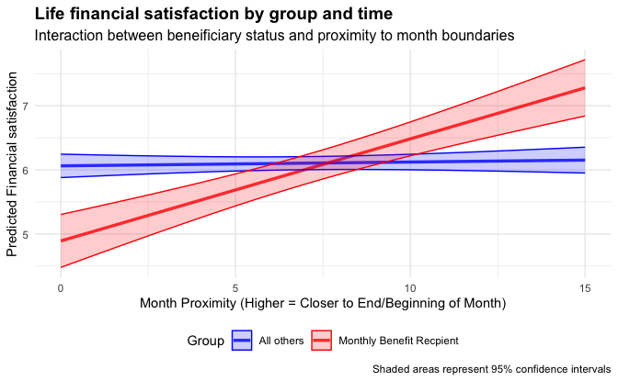

- Mechanisms to test:
  - As I currently see this, there are several rough hypothesis that we would be testing with this:
    - H1:Political credit-attribution:
      - If the higher salience of benefit programs is impacting political attitudes because benefit recipients are connecting their higher financial security to benefit programs, and are connecting that to politics, we would expect to see:
        - Greater trust in CA/QC government
        - Greater trust in CA/QC institutions
        - Greater degree of attachement, greater feelings of acceptance in CA/QC
      - H2: Better psychological affect
        - An alternative explanation would be that the greater financial security produces a better overall psychological affect, but no one that’s explicitly politicized. In other words, people feel better and have a general sunnier predisposition because they feel more financially secure, but are not connecting this explicitly to politics, they just feel better about life in general. Fortunately, we have measures that are theoretically unconnected to the governments that would dispersing these benefits: attitudes towards people are institutions in the home country. If the mechanism here is more positive psychological affect where they feel better about people in general, then we would expect to see
          - Warmer feelings towards people and institutions in their country of origin
  - Specific model specification: this is something I am still thinking about. I have done instrumental variables before and I have done

